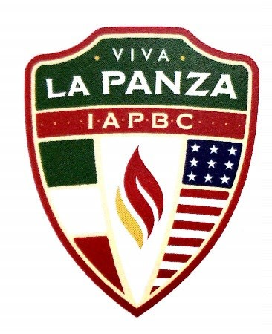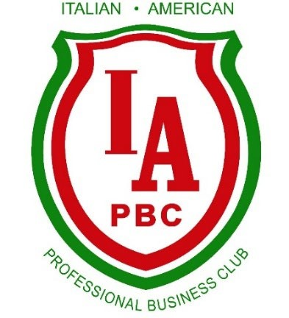***2025 IAPBC Annual Events***

Jan 29th – Wine Down Wednesday- Membership Mixer: (Sheraton Suites Akron Cuyahoga Falls)

March 19th – Wine Down Wednesday- Dual Citizenship Presentation with Board Member: John Vallillo (Papa Joes Iacomini’s)

April 23rd – Morra Tournament (Todaro’s)

May 15th - Scholarship Luncheon (Todaro’s)

June 18th – Wine Down Wednesday – Wine Tasting (Location TBD)

July 10th- 12th - Italian American Festival (Downtown Akron)

July 18th- 20th - Festa Italiana (Cuyahoga Falls)

July 28th - Golf Outing (Silver Lake CC)

August 6th – Wine Down Wednesday- Bocce Dinner (The Teodosio’s home)

September 20th – Volunteering at the Akron-Canton Regional Foodbank (Akron Location)

October 13th - Columbus Day (Location TBD)

October 29th - Viva La Panza – (Todaro’s)

December- Visits to Children’s Hospital and Stewart School

December 5th - Christmas GALA / Inaugural Dinner (Greystone Hall)