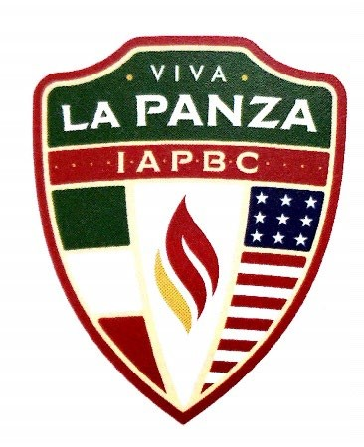
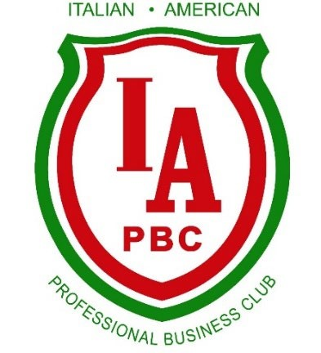
2024 IAPBC Annual Events

Feb 13th - Membership Mixer: Martedi Grasso Fat Tuesday (Sheraton Suites Akron Cuyahoga Falls)
March 27th- Bob DiBiasio, SVP Public Affairs CLE Guardians Lunch Speaker (Papa Joes Iacomini’s)
April 17th- Wine Down Wednesday: Italian Cultural Gardens Speaker (Dontino’s)
April 24th - Morra Tournament (Todaro’s)
May 16th - Scholarship Luncheon (Todaro’s)
June 19th- Wine Down Wednesday: Bocce Dinner (Location TBA)
July 11th- 13th - Italian American Festival (Downtown Akron)
July 19th- 21st - Festa Italiana (Cuyahoga Falls)
July 29th - Golf Outing (Silver Lake CC)
October 14th - Columbus Day (Location TBA)
October 30th - Viva La Panza – (Todaro’s)
December- Visits to Children’s Hospital and Stewart School
December 6th - Christmas GALA / Inaugural Dinner (Greystone Hall)

